Kubernetes Task-2

Task Description:

Create the K8s EKS,further you have to do the deployment of the Nginx application and access the application outside the cluster.

Techstacks needs to be used :

- AWS EKS
- EKSCtl
- Kubectl

OUTPUT:-

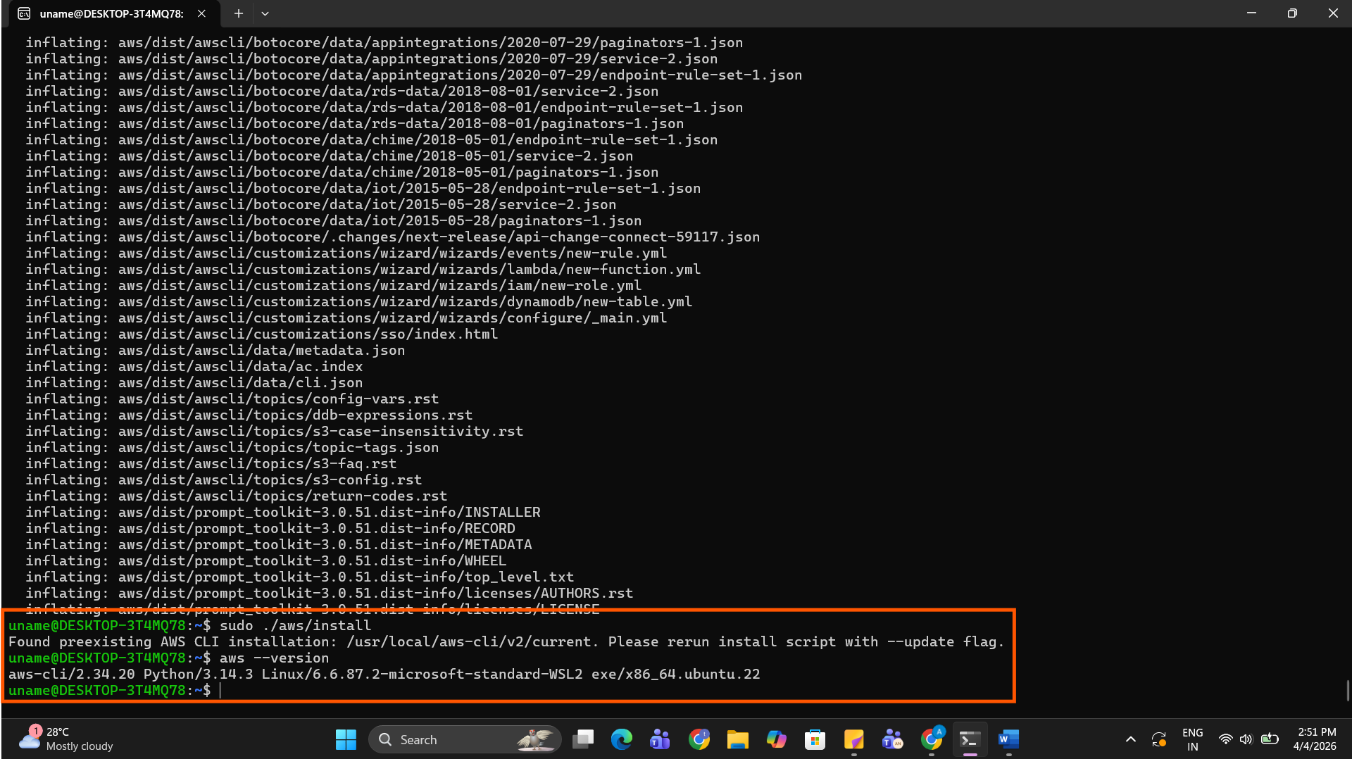

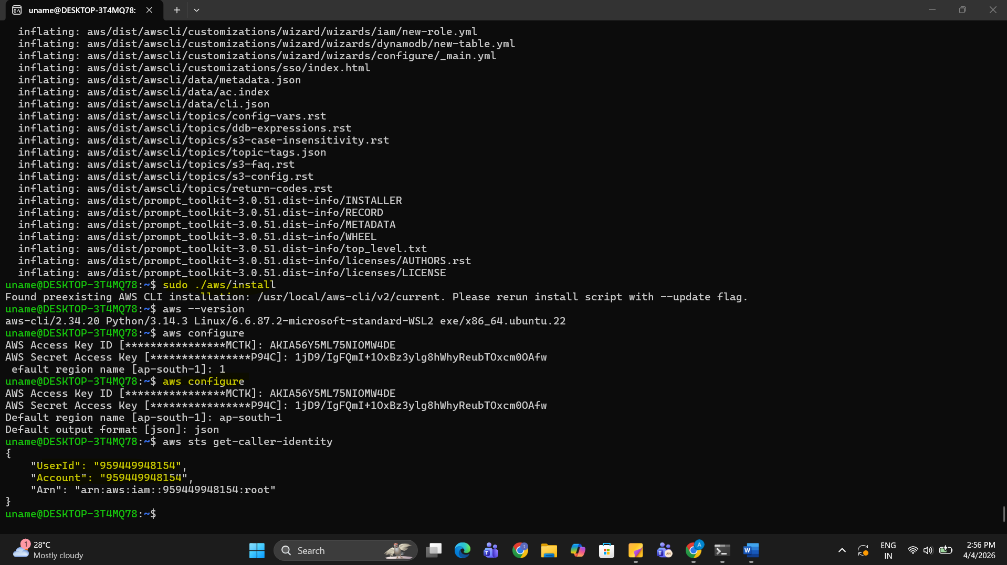

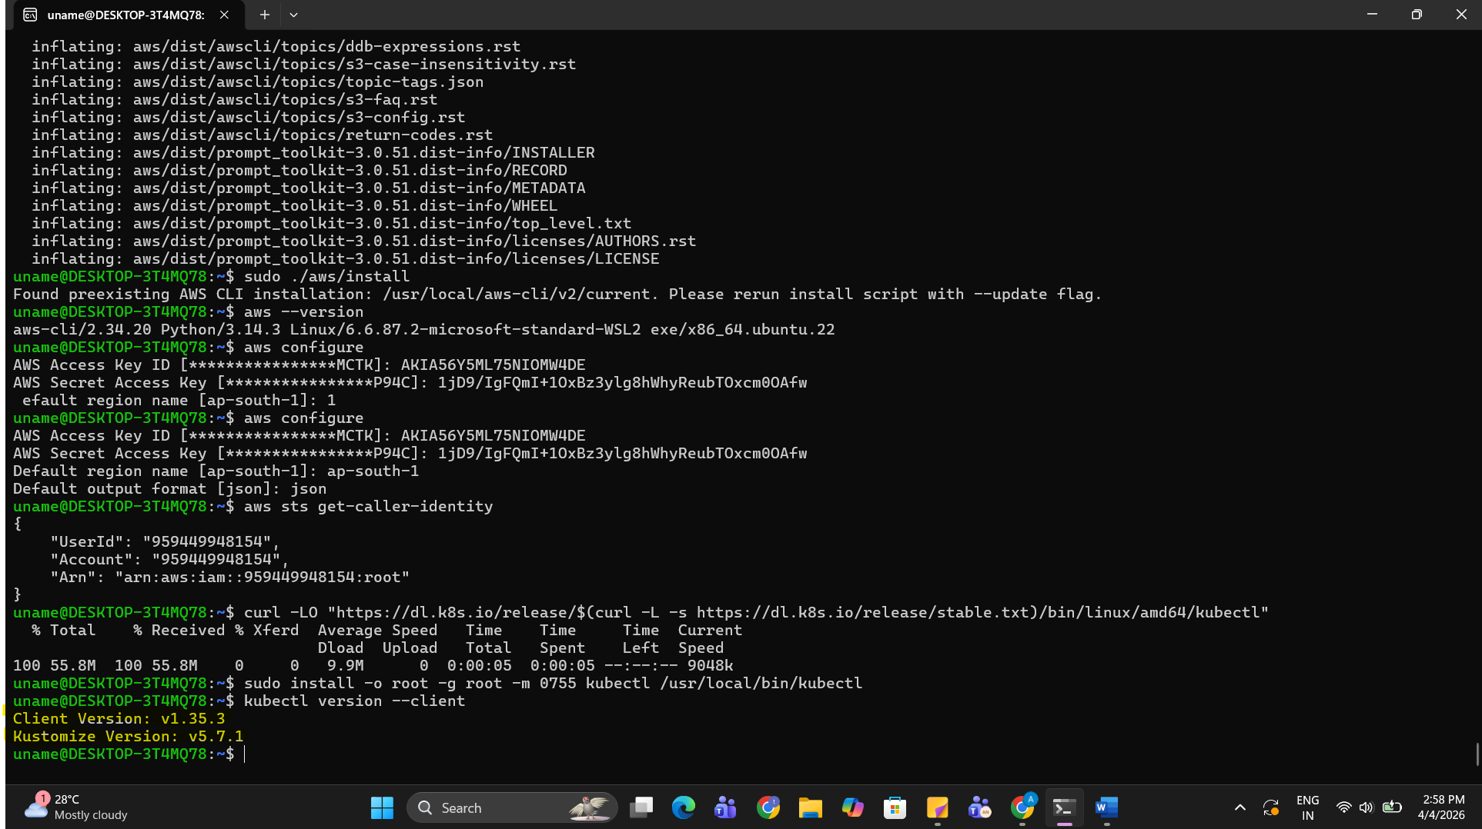

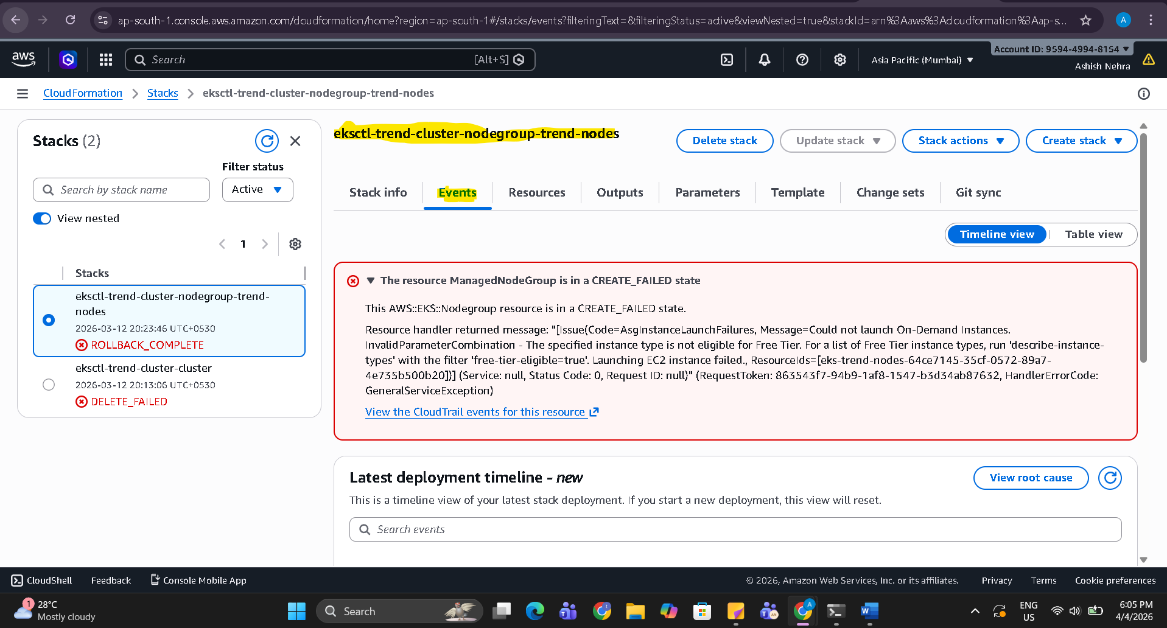

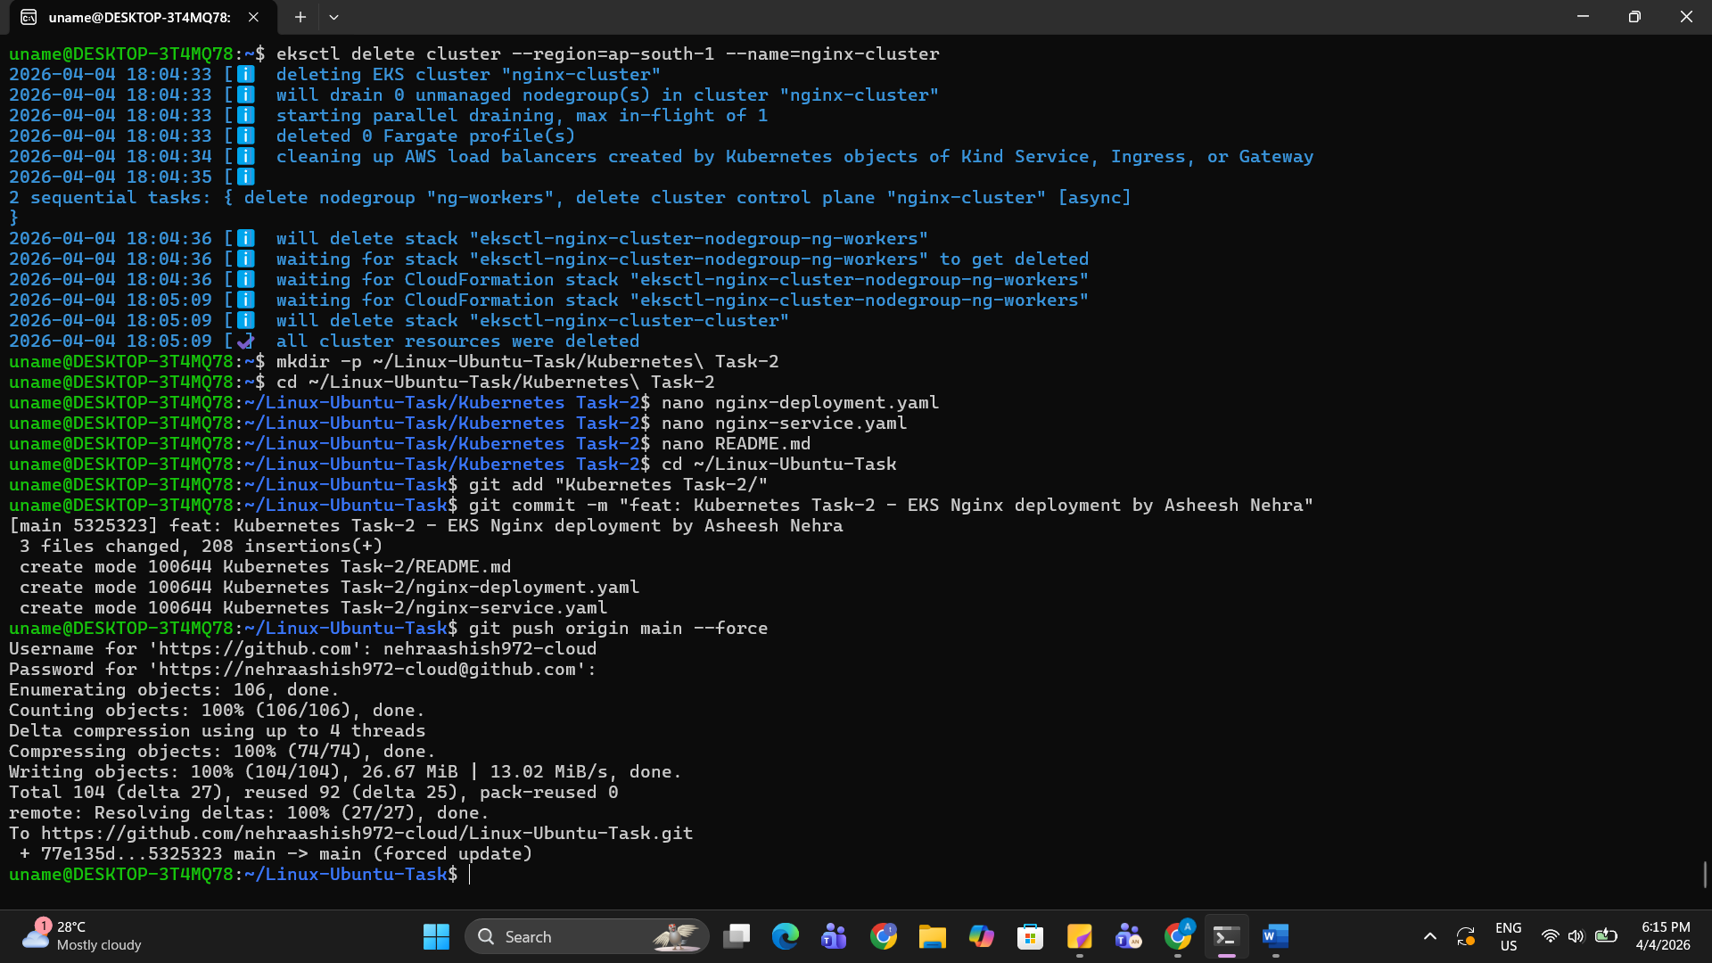

Task Status: Partially Completed — Infrastructure Ready

EKS Cluster Control Plane was successfully created in AWS (ap-south-1 region)
using eksctl. All installation steps were completed:
- AWS CLI v2 installed and configured
- eksctl v0.224.0 installed
- kubectl installed
- EKS cluster "nginx-cluster" created successfully

Issue Faced:
During NodeGroup creation, EC2 instance launch failed because new AWS accounts
have default vCPU quota = 0 for On-Demand Standard instances. Tried instance
types: t3.medium, t2.micro, t2.small — all failed with same quota error.

Action Taken:
Raised a Service Quota increase request for "Running On-Demand Standard
instances" in AWS Service Quotas console (ap-south-1 region).
Nginx deployment YAML and Service YAML files are ready to deploy once
quota is approved.

All code files and YAML manifests have been pushed to GitHub.

